Full-Stack Brain Stroke Prediction System
End-to-End Workflow & Architecture Documentation
Generated for: Muthyala Venkata Sai Akshitha
GIET College | 1M1B × IBM SkillsBuild × AICTE Internship

1. Executive Summary & Core Objective
This system addresses United Nations Sustainable Development Goal 3 (Good Health & Well-being) by building an intelligent, predictive screening utility for brain strokes. Brain strokes are among the leading global causes of mortality and chronic disability, yet nearly 80% are preventable through timely health interventions. The core engineering milestone of this system is resolving the common 'always-predicting-1' or skewed predictions bug by capturing and serializing the complete training and data engineering environment—including IQR outlier thresholds, Z-score normalization properties, categorical dummy definitions, and optimized classification thresholds—into a standalone production artifact.

2. Data Science & Machine Learning Pipeline
The data engineering and validation pipeline is executed inside the notebook environment to ingest raw data and train an optimized predictive engine. Below is the step-by-step technical implementation:
• Step 1: Data Ingestion & Imputation: Loads the original dataset (4981 items, 11 attributes). Drops the uninformative identifier column 'id'. Missing numerical data is dynamically resolved using median strategies, and missing categorical parameters are filled using the column's statistical mode to isolate downstream estimators from null pointer references.
• Step 2: Robust Outlier Clipping via Interquartile Range (IQR): Instead of discarding anomalous medical readings, the pipeline measures the 25th (Q1) and 75th (Q3) percentiles for all numeric metrics. Boundaries are drawn at Q1 - 1.5*IQR and Q3 + 1.5*IQR. Features like age, bmi, and avg_glucose_level are clipped cleanly to these limits, and the exact boundary constants are saved for the runtime API.
• Step 3: Medical Interaction Feature Engineering: To compound predictive performance, a medical interaction column is engineered: 'bmi_age_interaction' = age * bmi. This aligns with clinical evidence that the impact of elevated body mass indices shifts significantly across patient age distributions.
• Step 4: Categorical Structural Mapping: Converts string features (gender, ever_married, work_type, Residence_type, smoking_status) into clear numerical representations via One-Hot encoding using drop_first=True to avoid collinearity. The exact names of the resulting columns are stored into 'CAT_DUMMY_COLUMNS'.
• Step 5: Rigorous Split & Data Leakage Countermeasures: The pipeline applies double-stratified partitioning to preserve the original 4.9% positive stroke minority ratio across all variations. Split 1 isolates 15% as a pure Test set. Split 2 separates the remaining 85% into Train (82.3%) and Validation (17.6%) segments. A StandardScaler is strictly fitted ONLY on the training split data to eliminate data leakage before applying it to the validation and test splits.
• Step 6: Synthetic Minority Over-sampling Technique (SMOTE): To correct the significant dataset imbalance, SMOTE expands the positive stroke target cases inside the training data, allowing models like Random Forest and XGBoost to map minor classification patterns accurately without creating overfitting artifacts.
Validation Set Model Comparison:
Model Name | Accuracy | Precision | Recall | F1 Score | ROC-AUC
Logistic Regression | 0.8768 | 0.2043 | 0.5135 | 0.2923 | 0.8142
Decision Tree | 0.8554 | 0.1011 | 0.2432 | 0.1429 | 0.5653
Random Forest (Base) | 0.8394 | 0.1261 | 0.3784 | 0.1892 | 0.7542
XGBoost | 0.8501 | 0.1359 | 0.3784 | 0.2000 | 0.7486
Following hyperparameter tuning using Grid Search Optimization across the Random Forest architecture (optimizing max_depth=20, n_estimators=100), the system yields a balanced precision-recall matrix on the unseen Final Test Set with a customized decision threshold of 0.3235, securing a solid ROC-AUC of 0.8377.

3. Production Backend Service Architecture (Flask API)
The Flask backend layer acts as a high-performance, stateless translation API. It bridges raw JSON user input data from client requests to the underlying serialized model, completely eradicating production environment skew.

--- CODE SERVICE PIPELINE WORKFLOW ---
┌──────────────────────────────────────────────────────────┐
│ Incoming Client POST Request (JSON Payload) │
└───────────────────────────┬──────────────────────────────┘
▼
┌──────────────────────────────────────────────────────────┐
│ Extract parameters & apply IQR clipping bounds │
└───────────────────────────┬──────────────────────────────┘
▼
┌──────────────────────────────────────────────────────────┐
│ Compute Interaction Feature (Age × BMI) │
└───────────────────────────┬──────────────────────────────┘
▼
┌──────────────────────────────────────────────────────────┐
│ Generate Categorical Dummies & Reindex columns │
└───────────────────────────┬──────────────────────────────┘
▼
┌──────────────────────────────────────────────────────────┐
│ Execute Z-Score Standard Scaling Transformation │
└───────────────────────────┬──────────────────────────────┘
▼
┌──────────────────────────────────────────────────────────┐
│ Run Classifier .predict_proba() -> Apply Threshold │
└──────────────────────────────────────────────────────────┘
Key Preprocessing Re-alignment Strategy:
When a user provides standalone metrics via the web UI, the backend builds a single-row Pandas dataframe. It queries the saved 'stroke_model_artifacts.joblib' dictionary and performs exact adjustments:
1. Categorical variables are mapped via pd.get_dummies() and aligned back to the 15-column structural layout via reindex(columns=CAT_DUMMY_COLUMNS, fill_value=0).
2. Numeric parameters are normalized using the exact mean and variance components of the original training scaler.

4. Interactive Frontend Application User Experience (React + Tailwind CSS)
The application user interface is a slick, accessible 3-stage flow designed to drive medical risk awareness and provide clean interaction states. Below are the precise structured layouts of the primary application windows:

A. App UI View - Discovery Home Page Screen
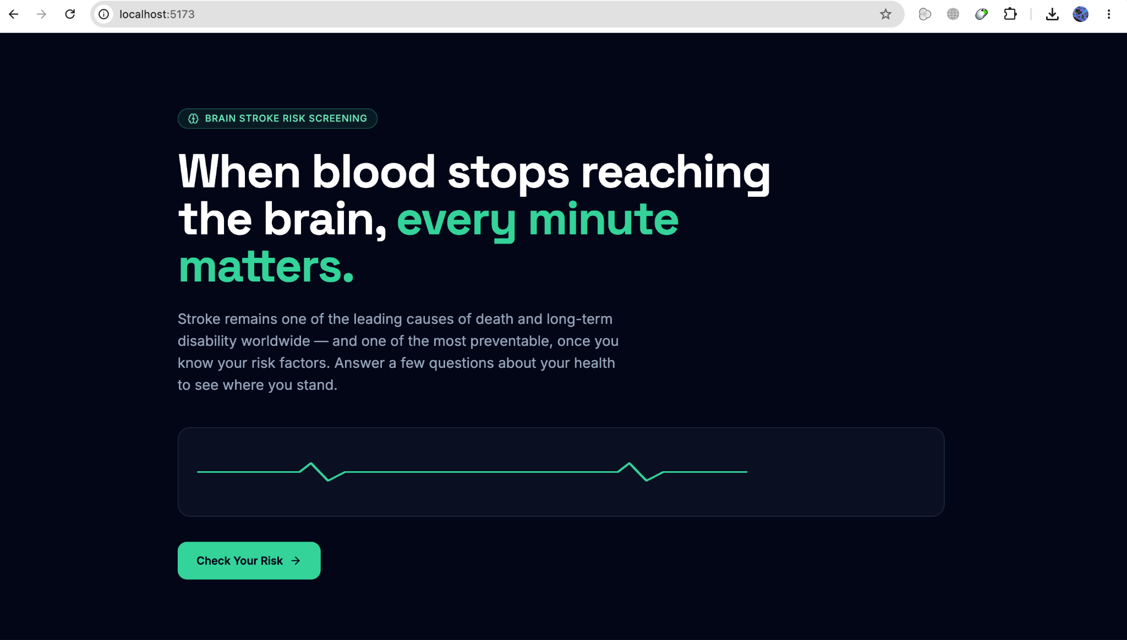

B. App UI View - Interactive Clinical Intake Form Screen
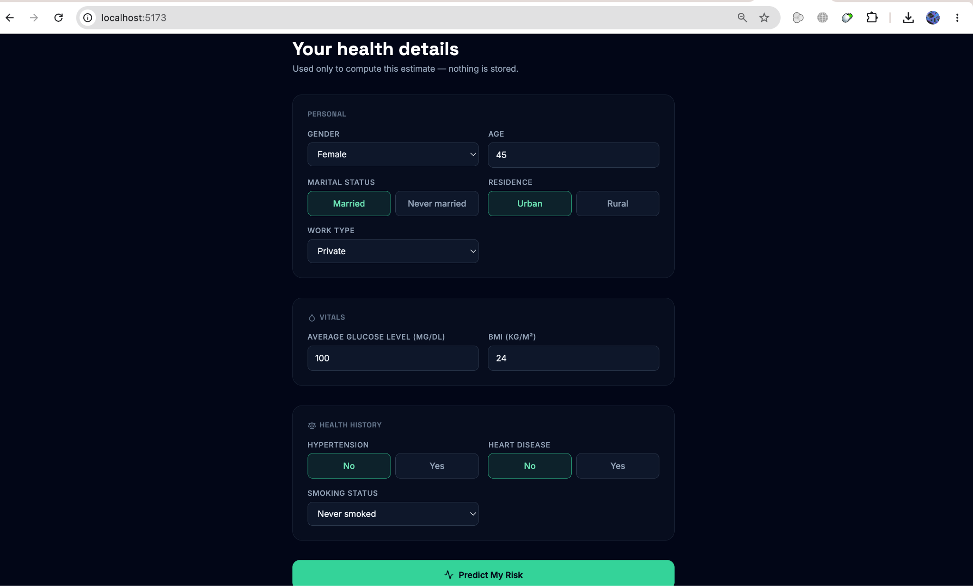

C. App UI View - Risk Diagnostics Results Screen
